A Game Of Pig

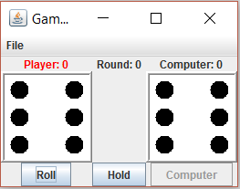

Silas Agnew

I pledge that this work is entirely mine, and mine alone (except for any code provided by my instructor).

I spent on the project from Oct. 7 to Oct. 29. See time sheet on back for more detail.

Time Sheet

|  |  |  |  |  |
| --- | --- | --- | --- | --- |
| Date | Time Started | Time Stopped | Duration | Worked on… |
| 10/7/2017 | 12:00:00 | 12:20:00 | 00:20:00 | Project creation and templating project |
| 10/8/2017 | 18:00:00 | 18:20:00 | 00:20:00 | Method body work |
| 10/24/2017 | 16:22:00 | 17:00:00 | 00:38:00 | More method work and finished modifying GUI |
| 10/29/2017 | 15:45:00 | 16:55:00 | 01:10:00 | Test methods and testing |
| 10/29/2017 | 20:15:00 | 20:45:00 | 00:30:00 | Testing and printout |
|  |  |  |  |  |
|  |  | Total Time | 02:58:00 |  |